Feedback Session 2

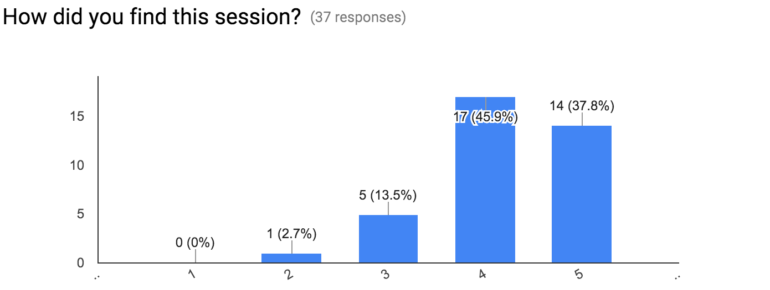

Any feedback you would like to give? (13 responses)

Great Session! Gave me a strong insight into the packages in Python.

Started very slow and ended really fast

good

Too fast the last step (CONDA INSTALL)

Very well run, with numerous small exercises

Great tutorial sessions with lots of examples.

Material is delivered too quickly at the end which means that everyone has the same problem.

Module could be covered as well, since this is a key feature of python for data science. Explaining why you use 2.7 might also be interesting.

As a suggestion we could have used IPython

Go a little faster

Tutorial was very useful.

The session is informative / tutorial style. Would it be possible to show how you apply python more interestingly?

Python enthusiast